Given a**directed acyclic graph**, with n vertices numbered from 0 to n-1, and an array edges where edges[i] = [fromi, toi] represents a directed edge from node fromi to node toi.

Find *the smallest set of vertices from which all nodes in the graph are reachable*. It's guaranteed that a unique solution exists.

Notice that you can return the vertices in any order.

**Example 1:**

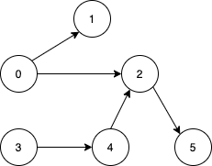

**Input:** n = 6, edges = [[0,1],[0,2],[2,5],[3,4],[4,2]]

**Output:** [0,3]

**Explanation:** It's not possible to reach all the nodes from a single vertex. From 0 we can reach [0,1,2,5]. From 3 we can reach [3,4,2,5]. So we output [0,3].

**Example 2:**

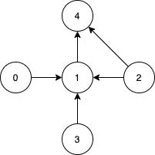

**Input:** n = 5, edges = [[0,1],[2,1],[3,1],[1,4],[2,4]]

**Output:** [0,2,3]

**Explanation:** Notice that vertices 0, 3 and 2 are not reachable from any other node, so we must include them. Also any of these vertices can reach nodes 1 and 4.

Solution:

class Solution {

public List<Integer> findSmallestSetOfVertices(int n, List<List<Integer>> edges) {

List<Integer> res = new ArrayList<>();

boolean[] inDegree = new boolean[n];

for(List<Integer> edge : edges){

inDegree[edge.get(1)] = true;

}

for(int i=0;i<n;i++){

if(!inDegree[i])

res.add(i);

}

return res;

}

}